5 Things To Tell Anyone Who Blames Black Lives Matter For Violence Against Cops

The argument that the Black Lives Matter movement is driving individuals to kill cops is ridiculous.
09/03/2015 11:32 am 11:32:07

Julia Craven Reporter, The Huffington Post
Nick Wing Senior Viral Editor, The Huffington Post
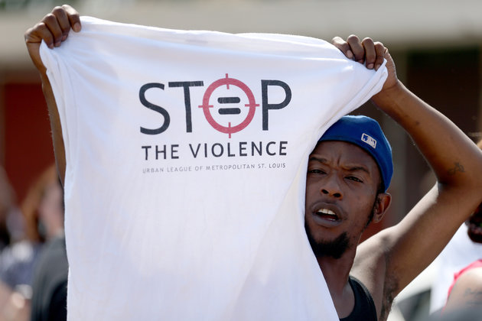
Credit: Joe Raedle via Getty Images
A protester advocates against police brutality in St. Louis.
Sheriff Ron Hickman of Harris County, Texas, isn’t quite sure why suspect Shannon J. Miles allegedly shot and killed his deputy, Darren Goforth, last week. Police investigating the homicide haven’t been able to identify a motive, but Hickman has a theory, and it involves Black Lives Matter.
“I think that’s something that we have to keep an eye on,” he said. “The general climate of that kind of rhetoric can be influential on people to do things like this. We’re still searching to find out if that’s actually a motive.”
Then he took more direct aim.
“We’ve heard black lives matter, all lives matter,” Hickman said. “Well, cops’ lives matter, too. So how about we drop the qualifier and just say lives matter?”
Fox News took this rhetoric and ran with it. “Fox & Friends” co-host Elisabeth Hasselbeck asked conservative writer Kevin Jackson why the Black Lives Matter movement hasn’t been classified as a “hate group,” and an onscreen banner the network ran labeled Black Lives Matter a “Murder Movement.” Bill O’Reilly later piled on.
On Wednesday, Hickman appeared on Fox News and said he isn’t quite sure if Black Lives Matter is to blame, but he still has his hunch. “You can’t help but wonder if there are people who are susceptible to the message that someone should lash out and make targets of police officers,” he said. “You can’t help but wonder.”
Wondering is fine, but directly accusing Black Lives Matter of promoting violence against police without any evidence is stereotyping at its finest. A black man allegedly killed a police officer, and now all black people involved in the movement are being indicted for the crime.
Black Lives Matter is an easy target because of its high-profile media presence and its ability to galvanize. Miles is held up as a representative of a group, rather than viewed as an individual — which frequently happens when it comes to race, for better or for worse. As Shaun King wrote for The Daily Kos: “Just because this man who killed Officer Goforth was black, doesn’t make him a part of this movement any more than being white qualifies you as a member of the Ku Klux Klan.”
The argument that the Black Lives Matter movement is driving individuals to kill cops is specious, and if someone brings it up, here are five things you can tell them.

1. Nobody doubts that being a cop can be hard and dangerous. But statistics show this is not any more true today than it was last year.
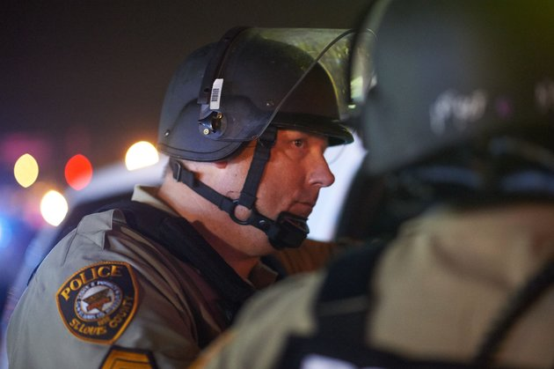
Credit: Michael B. Thomas via Getty Images
Police officers in Ferguson monitoring protests one year after 18-year-old Michael Brown was shot and killed by officer Darren Wilson.
And if statistics are any indicator, being a police officer may actually be less dangerous in 2015 than it was in 2014. According to numbers from Officer Down Memorial Page, an independent nonprofit that tracks cop killings, 24 officers were shot and killed in the line of duty so far this year, but 29 were killed during the same time period in 2014.
And while those 24 deaths are obviously tragic, 2015 has actually seen fewer year-to-date shooting deaths of police officers than nearly every other year in the past two decades. The lone exception was 2013, when the FBI says killings of police overall hit a 50-year low.
And to those who say the race of the officer matters in these targeted killings, half of the police shot and killed this year were black.

2. Resentment toward police officers who abuse their authority existed before Black Lives Matter.
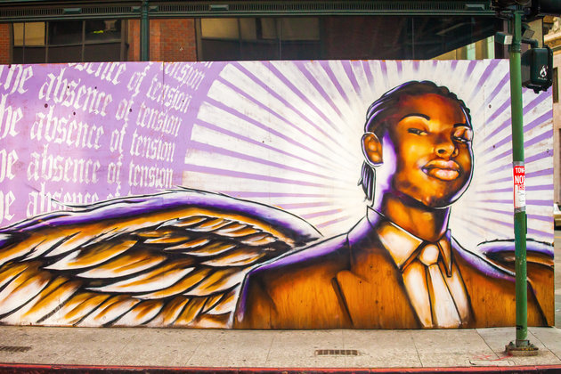
Credit: Thomas Hawk/Flickr
An Oakland mural of Oscar Grant, who was shot and killed by a BART police officer in 2009 — three years before the founding of Black Lives Matter.
Anyone who points to the “rhetoric” of Black Lives Matter as a root cause of violence doesn’t know anything about black history. In 1988, N.W.A released “Fuck tha Police” to protest police violence and racial profiling of the black community. The song, like hip-hop in general, and now Black Lives Matter, has often been blamed for the resentment black folks feel toward law enforcement. But this aggressive criticism of police, like the concerns voiced by Black Lives Matter, is a response to mistreatment at the hands of police officers. And it’s that mistreatment, not “rhetoric,” that continues to fuel this resentment.
On CNN in 2012, commentator LZ Granderson summed up why he — and many black folks — distrust law enforcement:
But when you’ve been pulled over for no good reason as many times as I have; when you’ve been in handcuffs for no good reason as many times as I have; when you run out to buy some allergy medication and upon returning home, find yourself surrounded by four squad cars with flashing lights and all you can think about is how not to get shot, you learn not to trust cops.
And to anyone who says Martin Luther King Jr. was more thoughtful with his rhetoric, remember that he was also blamed for inciting violence against the police. Simply put, when a movement is countering the dominant narrative with truth — and particularly, unapologetic truth — that movement is blamed for inciting violence. It’s a tired, old argument.

3. The idea that Black Lives Matter and the idea that the lives of cops (or anyone else) matter are not mutually exclusive.
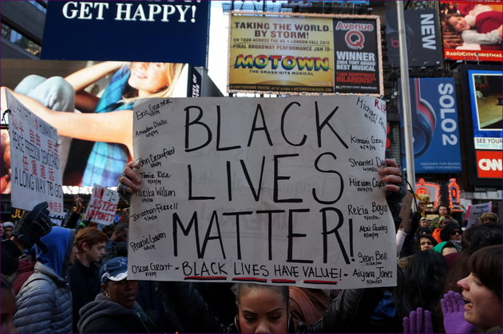
Credit: The All-Nite Images/Flickr
A Black Lives Matter protester holds up a sign during a march in New York City.
When people say “Black lives matter,” it is because this nation has made it clear that it often doesn’t agree. The phrase “black lives matter” does not — and has never meant — that the lives of police officers, or anyone else, don’t matter. As Janell Ross pointed out in The Washington Post:
To Hickman and more than a few law enforcement union leaders and public spokesmen around the country, it seems that in a world in which Black Lives Matter, police lives accordingly do not. That sounds a lot like saying that effective policing and law enforcement where officers feel and remain safe cannot happen unless those same public officials are free to do their work without regard for the civil rights and liberties of people of color in the communities they police.
A cop getting murdered is awful. Their lives do matter. But to place blame on the Black Lives Matter movement and claim it promotes the idea that only black lives have meaning is false, divisive and especially misguided. The movement’s premise is that all lives are important, but every life isn’t treated as such.

4. The Black Lives Matter movement doesn’t promote violence against police officers or anyone else.
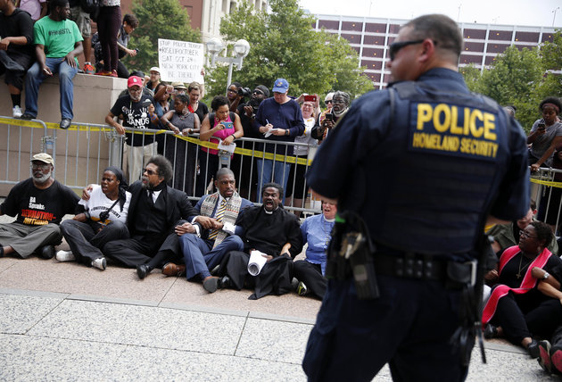
Credit: Jeff Roberson/Associated Press
Protesters sit in front of Thomas F. Eagleton Federal Courthouse in St. Louis, Missouri on Aug. 10, 2015.
No one who claims to speak for the Black Lives Matter movement has promoted violence as a means to achieve an end. The message the movement spreads has nothing to do with inflicting violence or pain against police officers — or anyone else, for that matter. It is simply a call to end the police brutality and misconduct that disproportionately take a toll on black bodies. As Vox points out, these goals are mutually beneficial:
It’s entirely possible to simultaneously want to reduce police shootings and want to keep police officers safe. Black Lives Matter activists have proposed at least 10 policies that aim to hold law enforcement accountable without putting them in harm’s way, ranging from ending aggressive low-level policing and instituting better police training to limiting standards for use of force and equipping cops with body cameras.
Furthermore, if Black Lives Matter is a movement committed to enacting reform through systemic change to policing priorities and tactics, how, exactly, would killing a cop help them in that goal?
That’s not to say that people haven’t said inappropriate things at protests against police violence, but the actions of a few, again, do not represent the majority. The fact that critics of Black Lives Matter seize upon one impolitic act while ignoring the rest of the movement’s message, again, speaks to a broader disconnect in this debate.

5. Cop killers face the full punishment of the law, and everyone thinks that’s how it should be.
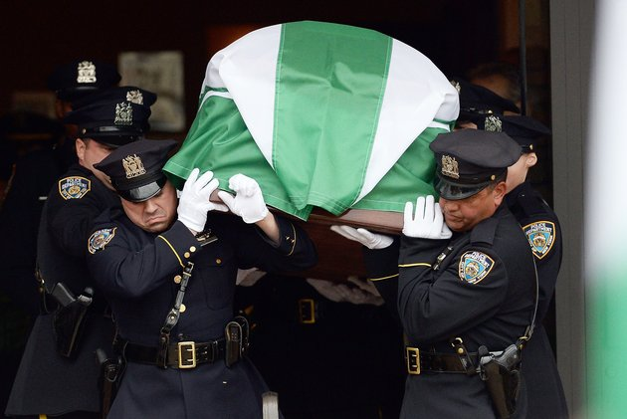
Credit: Jewel Samad via Getty Images
Officers carry the casket of Wenjian Liu, a NYPD officer killed along with his partner, Rafael Ramos, in December 2014.
When a civilian kills a cop, justice is swift. Lamont Pride, Christopher Monfort and Myles Webster, who all killed cops, were punished to the full extent of the law. Cops, on the other hand, are less likely to be convicted for killing a civilian.
Even over the past year, the cops who killed 18-year-old Michael Brown, 19-year-old Tony Robinson, 22-year-old Rekia Boyd and 43-year-old Eric Garner faced no legal repercussions for their actions. And despite the controversy, many people both in and out of law enforcement saw no problem with those decisions.
There’s a glaring double standard here. Police officers are heavily protected by the legal system: they are authorized to use force in ways civilians are not; their excessive force cases are often investigated by members of their own department; and most people are reluctant to second-guess an officer’s decision to use force — even in courtroom settings.
Granted, at least 41 cops have been indicted on murder or manslaughter charges this year for killing civilians in the line of duty. But a 2015 Washington Post analysis found that of the thousands of fatal shootings by police since 2005, only 54 officers have been charged. Far fewer were actually convicted.

