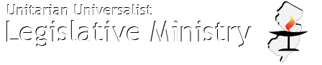
UULMNJ April Plenary
The “General Assembly” for UUULULMNJ and supporters from across New Jersey:
Saturday, April 8 * 9:00 a.m. - 3:00 p.m.
Unitarian Society of Ridgewood, 113 Cottage Place, Ridgewood NJ
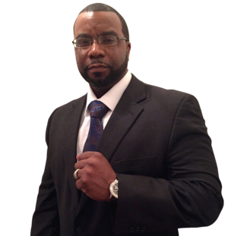
Keynote Speaker:
The Rev. Charles Boyer
African Methodist Episcopal minister, inspirational speaker, and NJ legislative activist
Theme for the day:
“All that UULMNJ CAN do to push for justice and stand against the inequities of Trump and Congress’ plan for America”
Task Force meetings:
Immigration Reform, Gun Violence Prevention, Criminal Justice Reform, Environmental Justice, Reproductive Justice, and Economic Justice
Liaison and Newcomers Training Opportunity
Why come to the UULMNJ April Plenary?
Simply put: because we already have a clear VISION, TRACK RECORD, and UU-inspired
ORGANIZATION up and running, ready to champion our liberal religious values in the public square.
UULMNJ focuses entirely on the most important issues of the day that excite (and rile up) UUs and our allies across New Jersey. So come on DOWN, share in that energy and spirit that draws us to this faith and will propel us forward, together, through whatever is to come.

