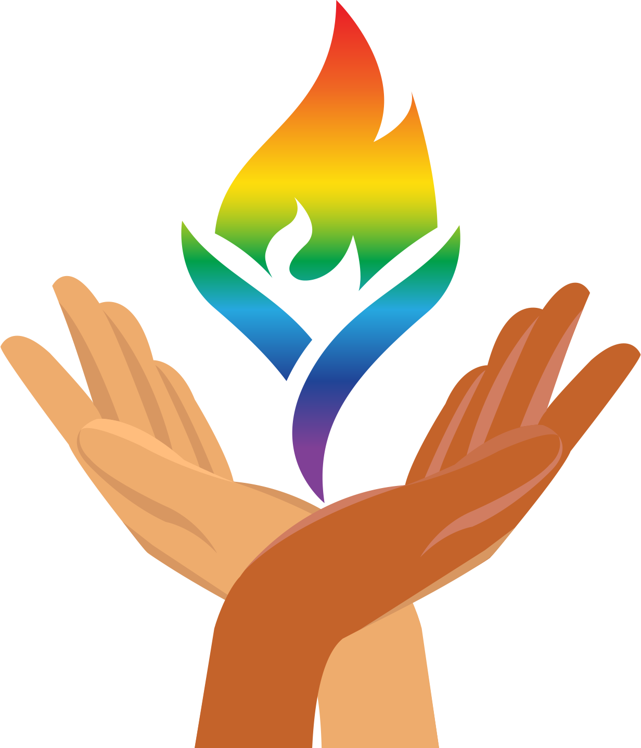

UUCP and Interfaith Prison Partnership
Prison Release Bags Donation Initiative 2022

Women being released from prison leave with little to no essential items, not even so much as a toothbrush or comb.

Oftentimes they are released to homeless shelters rather than to loving and supportive family environments. In order to carry what few items they may have – some medication or an ID – they are only provided with a trash bag.

Interfaith Prison Partnership (IPP) seeks to do more to affirm the human dignity of incarcerated people and support their re-entry. Thus, in conjunction with the town of Bedford’s Prison Advisory Committee (PRAC), that have developed a program to provide Release Bags to women upon their exit from Bedford Hills and Taconic facilities.

They are seeking donations of some basic personal care items, including the following:
- shampoo & conditioner
- deodorant & soap
- feminine hygiene items
- lip balm & hand lotion
- sanitizer & Kleenex
- masks
- hair ties & comb/brush
- wash cloth & towel
- fleece blanket
- pens & notebook
- hard candy or gummies

All of these items can be easily purchased and shipped directly from Amazon.com using the following “Bright Hope Project” link:
https://www.amazon.com/hz/wishlist/ls/7IWORCKZ7M4D?ref_=wl_share

Items and Check donations can be sent to :
IPP, c/o Katonah Presbyterian Church, 31 Bedford Rd., Katonah, NY 10536.

For more information, contact:
Interfaith Prison Partnership - Rev. Elizabeth at revelizabeth@1spirit.org
UUCP Racial & Social Justice Team - Rev. Sonia Ketchian revsoniaketchian@gmail.com

